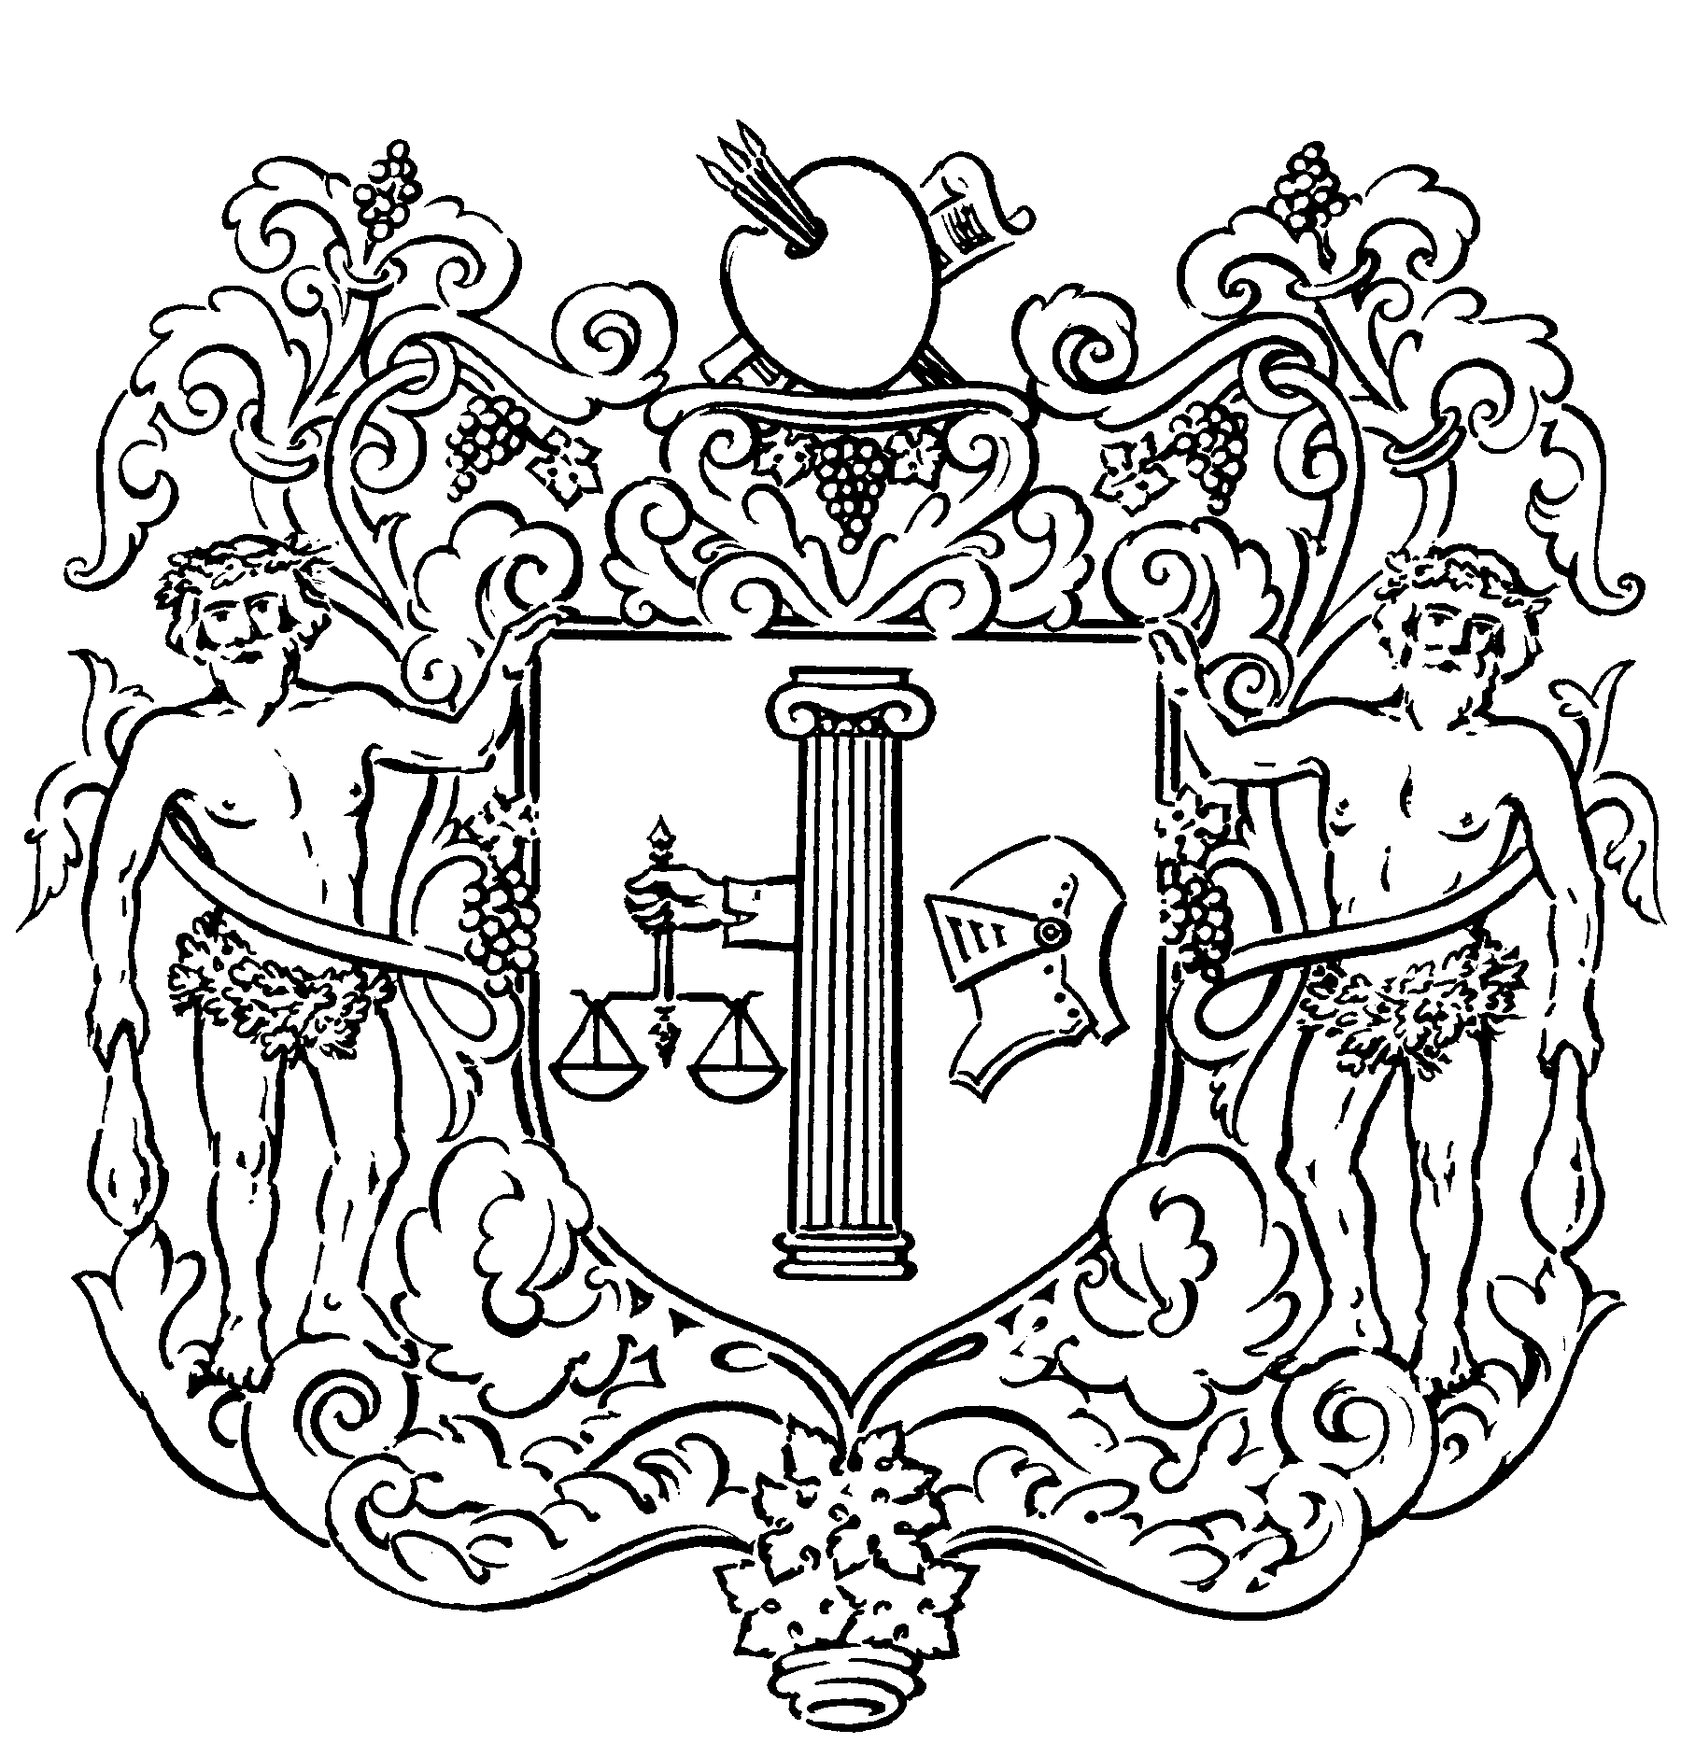

ANDIPA GALLERY
DEALERS IN FINE ART SINCE 1593

BANKSY
Wednesday 28 February – Saturday 24 March 2007

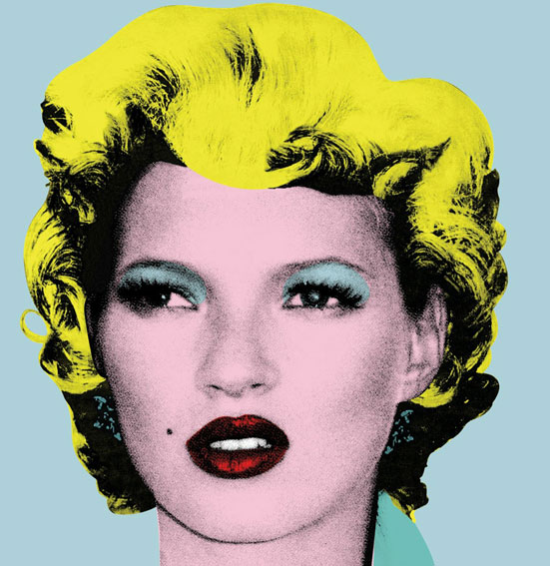

‘Kate’, 2005

Andipa Gallery presents the work of graffiti artist Banksy at its Knightsbridge premises from Wednesday 28 February – Saturday 24 March 2007. The show will incorporate 15 unique signed canvases and over 30 signed limited edition prints.

From the street-wise 14 year-old who began spraying graffiti on the walls of inner-city Bristol, Banksy has come a long way, creating quite the media storm in the process. With a distinctive stencilling technique and politically charged humour, Banksy’s work has appeared in cities around the world; from depicting the Queen as a chimpanzee during her Golden Jubilee, to smuggling an image of a Tesco’s tomato soup can onto the walls of the Museum of Modern Art, New York, where it remained unnoticed for six days. Now believed to be 28, it is Banksy’s anonymity that has enabled him to continue secretive and subversive stunts in prominent public places.

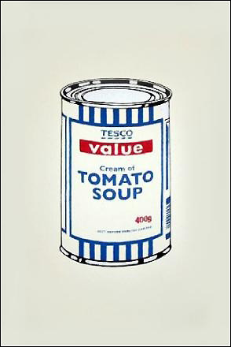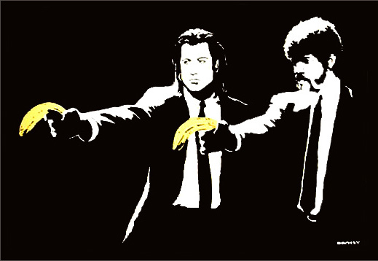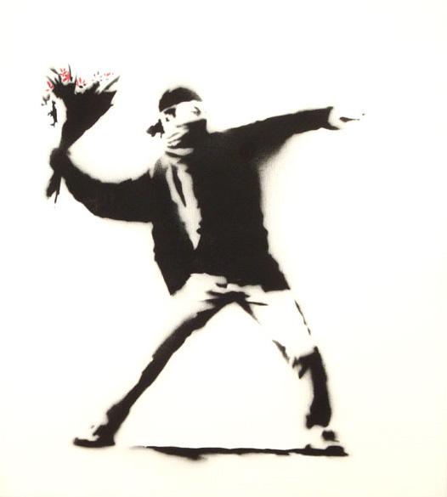

‘Soup Can’, 2005 ‘Pulp Fiction’, 2004 ‘Love Is in the Air’, 2003

Cont’d…
162 walton street knightsbridge london SW3 2JL united kingdom
tel 020 7589 2371 fax 020 7225 0305 art@andipa.com www.andipa.com

modern & contemporary byzantine art
london new york

vat no. 788 5704 70 company no. 4272027

Political in nature, Banksy’s works exude anti-war, anti-capitalist, anti-establishment sentiment. A helicopter gunship glides with a pink ribbon beneath its rotors, a bomber hurles a bunch of flowers, kids climb upon a mound of guns and the napalmed girl from Vietnam runs with Mickey Mouse and Ronald McDonald at either side. Each of these works will be presented within the exhibition.

Banksy has also taken great influence from Andy Warhol. During his first exhibition in 2003, entitled Turf War, a cow covered in images of Warhol’s face mingled amongst police-coloured pigs and sheep bearing concentration camp stripes. Kate Moss has since been immortalized with a small series of works entitled Kate, fashioned in the style of Marilyn Monroe, while Warhol’s Campbell’s Soup series has been adapted through Banksy’s portrayal of Tesco Value Soup Cans.

Banksy’s political standing and personal wit have gained him great recognition and the market reflects his success, his works recently commanding prices in excess of £100,000. An anonymous character, Banksy converses with the viewing public through the statements of his works alone. Even as buyers Angelina Jolie, Jude Law and Brad Pitt turned up to a Los Angeles warehouse to view his latest exhibition, Banksy himself did not deign to advertise his appearance. While one may not be privileged to his face, Andipa Gallery provides an inviting look into the cleverly witty, gently subversive and often beautiful works that make Banksy’s voice present.

Prices start from £5,000 - £100,000

- - - - - - - -

Artwork by Banksy will also be available at Andipa Gallery’s exhibition at Gstaad Palace, Switzerland, from Monday 12 – Saturday 17 February 2007, where original works and limited edition prints by Picasso, Matisse, Miro, Warhol, Lichtenstein, Hirst and Banksy will be for sale.

For further information and photographic material, please contact:
Gail McGuffie PR
Telephone: +44 (0)20 8568 5466
Mobile: +44 (0)7885 10 33 53
Email: MGailMcG@aol.com

Notes to Editors:

Banksy catalogue will be available.

Opening Hours: 09.30 – 18.00 hours (Monday – Friday)
11.00 – 18.00 hours (Saturday)

The Andipa Gallery also deals in a wide range of modern and contemporary artists, from Picasso to Warhol and a selective group of highly talented emerging artists. Andipa Gallery’s collection comprises largely of original works on paper, including drawings, paintings and signed limited edition prints.

www.andipa.com

